

**Fast-Food**

by

Abhishek EV (2147204)

Abhishek Anand (2147203)

Adhokshaja Acharya (2147205)

Under the guidance of

Prof. Sibu Cyriac

A Project report submitted in partial fulfillment of the requirements for the award of degree of Master of Computer Applications of CHRIST (Deemed to be University)

May - 2022

CERTIFICATE



*This is to certify that the report titled* **Fast-Food**

*is a bona fide record of work done by* ***Abhishek Anand (2147203), Abhishek EV (2147204), Adhokshaja Acharya (2147205)*** *of CHRIST (Deemed to be University), Bengaluru, in partial fulfillment of the requirements of III Trimester MCA during the year 2022.*

**Head of the Department Faculty In charge**

|  |  |  |  |
| --- | --- | --- | --- |
| Valued-by: |  | Names : | Prof. Sibu Cyriac  Libin Thomas |
|  |  | Register Number(s) : | 2147203  2147204  2147205 |
|  |  | Examination Center : | CHRIST (Deemed to be University) |
|  |  |  |  |
|  |  | Date : | 22-05-2022 |

**ABSTRACT**

The purpose of this college canteen management system ( pre-canteen ordering system ) is to help the students to get their food on time without wasting much time. This management system can lead to error free, secure, reliable and fast management system. Students can pre order their food via laptop and mobile sitting in the classroom or anywhere. They have to make payment first. This system will help students to save their time. Students will not have to wait in queue or wait for food to come on time. After pre-ordering, students will get a code and they have to show this code to the canteen's employee to get their food. This system will also be helpful for the admin ( canteen manager ). The purpose of Company Canteen Management System is to automate the existing manual system by the help of computerized equipments and full fledged computer software, fulfilling their requirements, so that their valuable data/information can be stored for a longer period with easy accessing and manipulation of the same.The required software and hardware are easily available and easy to work with. This will also be helpful for canteen workers because of this system they will already know how much food they will have to cook, so they can manage all those requirements before time. This will also prevent food wasting. This pre-canteen ordering system will be helpful for both students and workers of the canteen.

**TABLE OF CONTENTS**

**1 Introduction ………………………………………………………………………………………………... 1-2**

1.1 Overview…………………………………………………………………………………………………... 1

1.2 Existing System and Disadvantages……………………………………………………………………….. 1

1.3 Proposed System and Advantages…………………………………………………………………………. 2

**2 Requirement Specification………………………………………………………………………….……… 3-6**

2.1 Requirement Description……………………………………………………………………………………3

2.2 Use case diagram............................................................................................................................................6

**3 Detailed Design………………………………………………………………………………………...…...7-12**

3.1 Architectural Diagram……………………………………………………………………………………..7

3.2 Entity Relationship Diagram………………………………………………………………………………8

3.3 User Interface.......………………………………………………………………………………………....9

3.4 Table Description..………………………………………………………………………………………...10

**4 Construction……………………………………………………………………………………………..13-14**

4.1 Software and Hardware Environments…………………………………………………………………13

**5 Testing……………………………………………………………………………………………………..15-20**

5.1 Test Cases………………………………………………………………………………………………..15

5.2 Module Integration plan…………………………………...…………………………………………..…20

5.4 Defects………………………………………………………………………………………………..…..20

**6 Screenshots………………………………………………………………………………………………21-25**

6.1 Index Page…………..………………………………………………………………………………..…21

6.2 Login Page…………………………….............……………………………………………………..…21

6.3 Registration page….......……………………………………………………………………………......22

**6.4 User Dashboard………………………………………………………………………………….……22**

6.4.1 Home page……………………………………………………………………………………...........22

6.4.2Cart page……………………………………………………………………………………...............23

6.4.3 Delivery Detail page……………………………………………………………………....…............23

6.4.4 Payment Page…………………………………………………………………………….……..........24

**6.5 Admin Dashboard……………………………………………………………………………….........24**

6.5.1 Home page…………………………..........………………………………………………………......24

6.5.2 Add New Item………..................……………………………………………….………………........25

6.5.3 Edit Canteen Info…………………………………………………………………………………......25

**7** **Coding…………………………………………………………………………………………………...26-38**

7.1 Index Page……………………………………………………………………………………………........26

7.2 userdash.html................................................................................................................................................29

7.3 cart.html... ………………………………………………………………………………………………....35

7.4 urls.py .…………………………………………………………………………………………….............41

7.5 models.py......................................................................................................................................................42

7.6 views.py........................................................................................................................................................45

**8 Conclusion and Learnings…………………..…………………………………………………………......51**

**CHAPTER 1**

**INTRODUCTION**

**OVERVIEW**

This project aims to provide a platform for students to pre-order food from the canteen to get the food delivery (pick up) on time. The problem with the current system in college canteens is that the students have to order and wait for the food. This project aims to eliminate the wait time giving options for the students to place the order beforehand, and the canteen can keep the food item cooked and ready to eat. Students can pay the bill at the time of ordering or delivery. The order will generate a reference ID (QR code) that the canteen worker can scan and confirm.

This allows students to save time wasted on standing in queues to order, make payment, wait for the food to be cooked, etc.

**EXISTING SYSTEM: -**

As of now there are no specific applications for canteen pre-ordering. The working of this application is similar to what swiggy or zomato does. But college canteens are not included in those. IRCTC E-Catering is another application that allows users to book food to be delivered to their seats on a train.

**DISADVANTAGES OF EXISTING SYSTEM: -**

* Existing system is manual.
* It is time consuming.
* It is not reliable.
* It creates chaos during lunch time.
* It is difficult for employees to manage all the data manually.

**PROPOSED SYSTEM: -**

It’s basically an automation of food ordering that we do in the college canteen. This will help the user by saving time. We know the students only get a maximum 1 hour lunch break, in the traditional system they will have to spend most of the time in the queue itself.This can be avoided by an automation of the booking so that they can

book their favorite food without wasting their valuable time in a long queue.They can spend the saved time in other academic and extracurricular activities.

**ADVANTAGES OF PROPOSED SYSTEM: -**

* It is not time consuming.
* It is user friendly.
* It is reliable.
* It is helpful for shop to manage all the data of employees and the menu of food.
* It prevents food wasting.

**TOOLS: -**

1. HTML and CSS

2. JavaScript

3. MySQL

4. Django

**CHAPTER 2**

**SOFTWARE REQUIREMENTS**

**1) LOGIN: -**

-> The system must provide facilities to login and sign up for customers.

-> The system must provide facilities to login and sign up for shops.

-> If the username and password match, the user should be able to login.

-> System must provide a facility to reset the password.

**2) CANTEEN MANAGEMENT: -**

->The system must provide facilities for canteen owners to update the menu (Food menu).

->The system must provide facilities for canteen owners to see the orders.

-> The system should provide canteen owners to track past orders and change the status of orders. 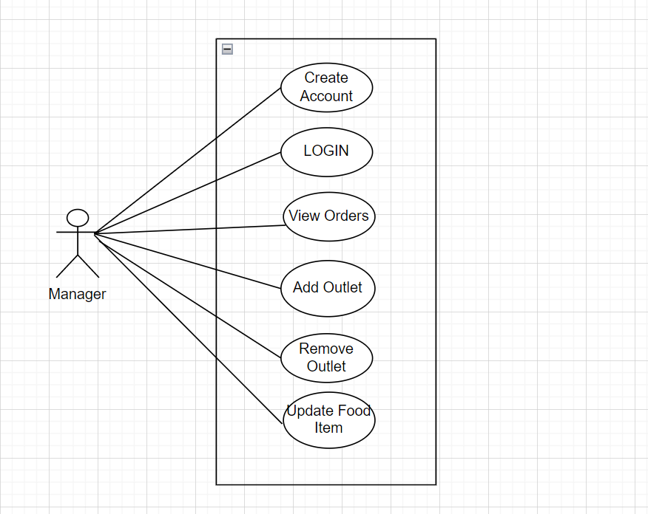

Fig 2.1:- Manager Use Case Diagram

**3) CUSTOMER MANAGEMENT: -**

-> System must provide facilities to select the outlet from the list given.

-> It must list the available items in the selected shop.

-> System must provide facilities for the customers to add multiple items to the cart.

-> System should provide facilities for the customers to track the status of their orders.

-> System should provide the facility to get the feedback from users. - > -> It is Nice to have the facility to request delivery to their classroom

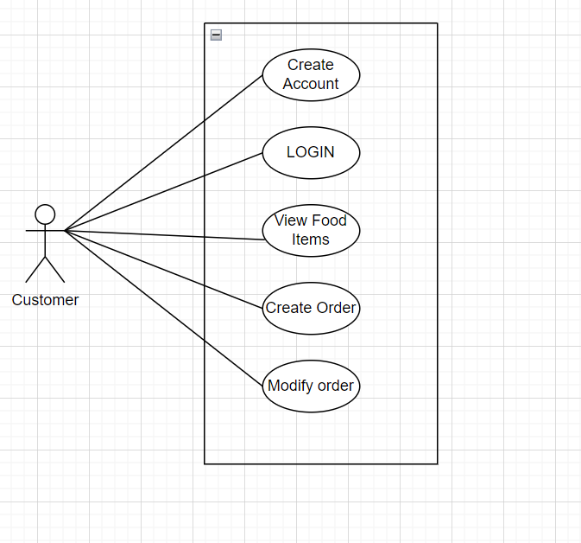

Fig 2.3: - Customer Use Case Diagram

**4) ORDER MANAGEMENT: -**

-> System must provide options for users to create and modify orders

-> System must provide options for canteen managers to view orders

-> System must provide options for chefs to view and modify status of the orders

-> System must generate a unique code or QR code to allow users to pick up the ordered items.

**5) PAYMENT MANAGEMENT: -**

-> System must ensure all involved parties get status of payment.

-> System must provide facilities for handling Refunds on cancellation.

-> Payment gateway integration.

**FAST FOOD USE-CASE DIAGRAMS**

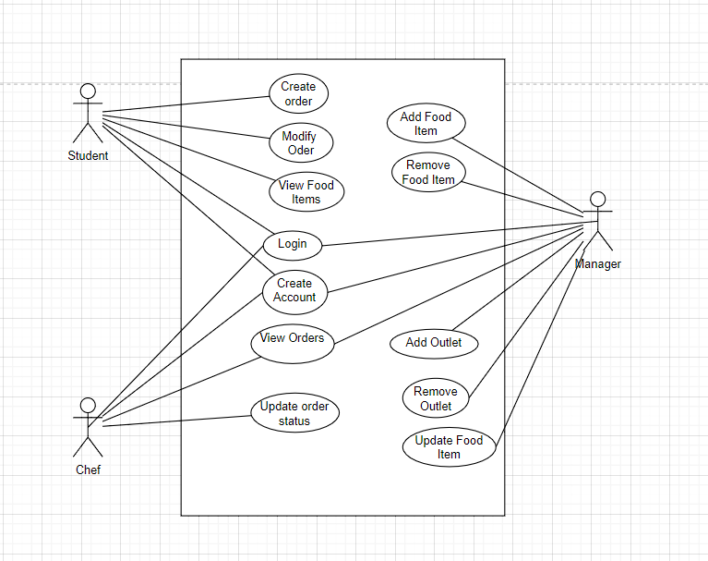

Fig 2.4: -Use Case Diagram of Fast_Food

**CHAPTER 3**

**DETAILED DESIGN**

**3.1 ARCHITECTURE DIAGRAM**

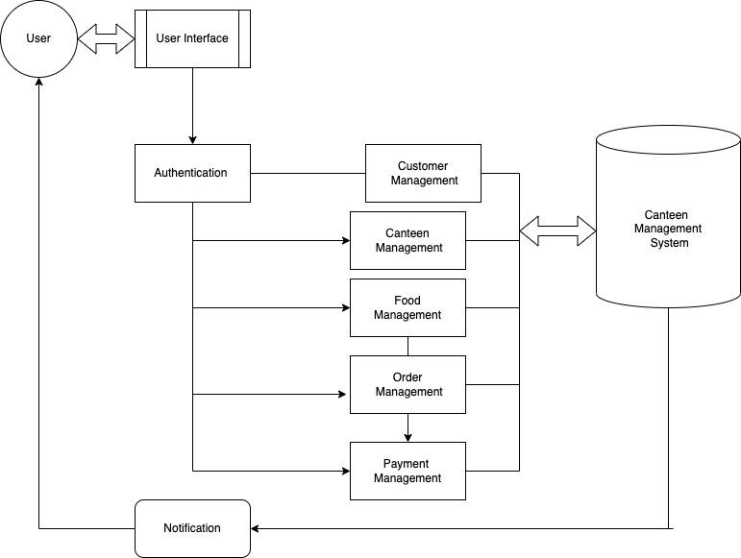

Fig 3.1:- Architecture Diagram

**3.2 ER DIAGRAM**

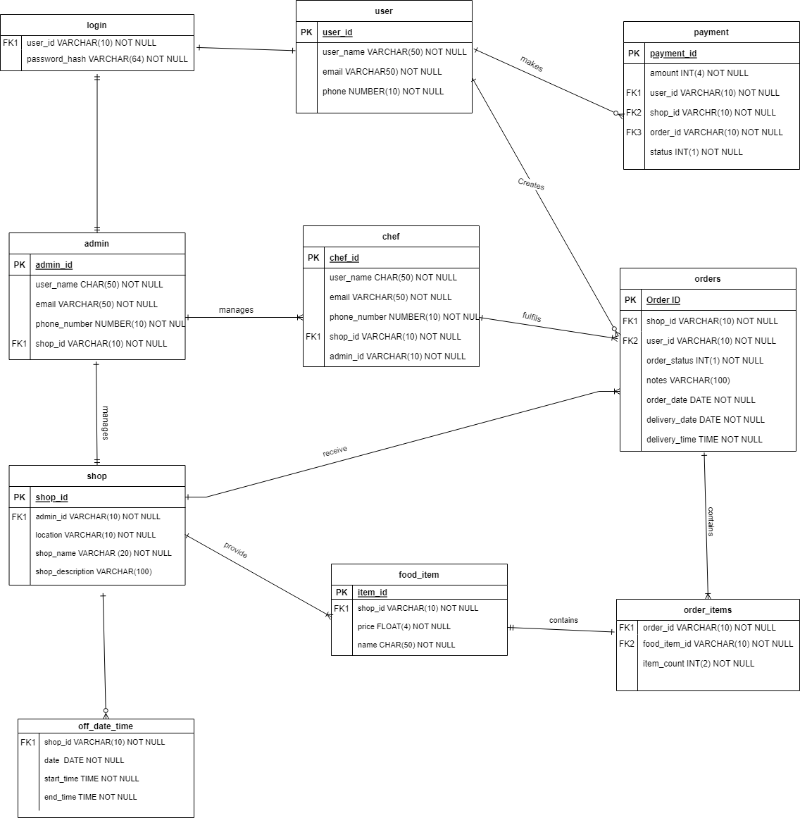

Fig 3.2: - ER Diagram

**USER INTERFACE**

Landing page

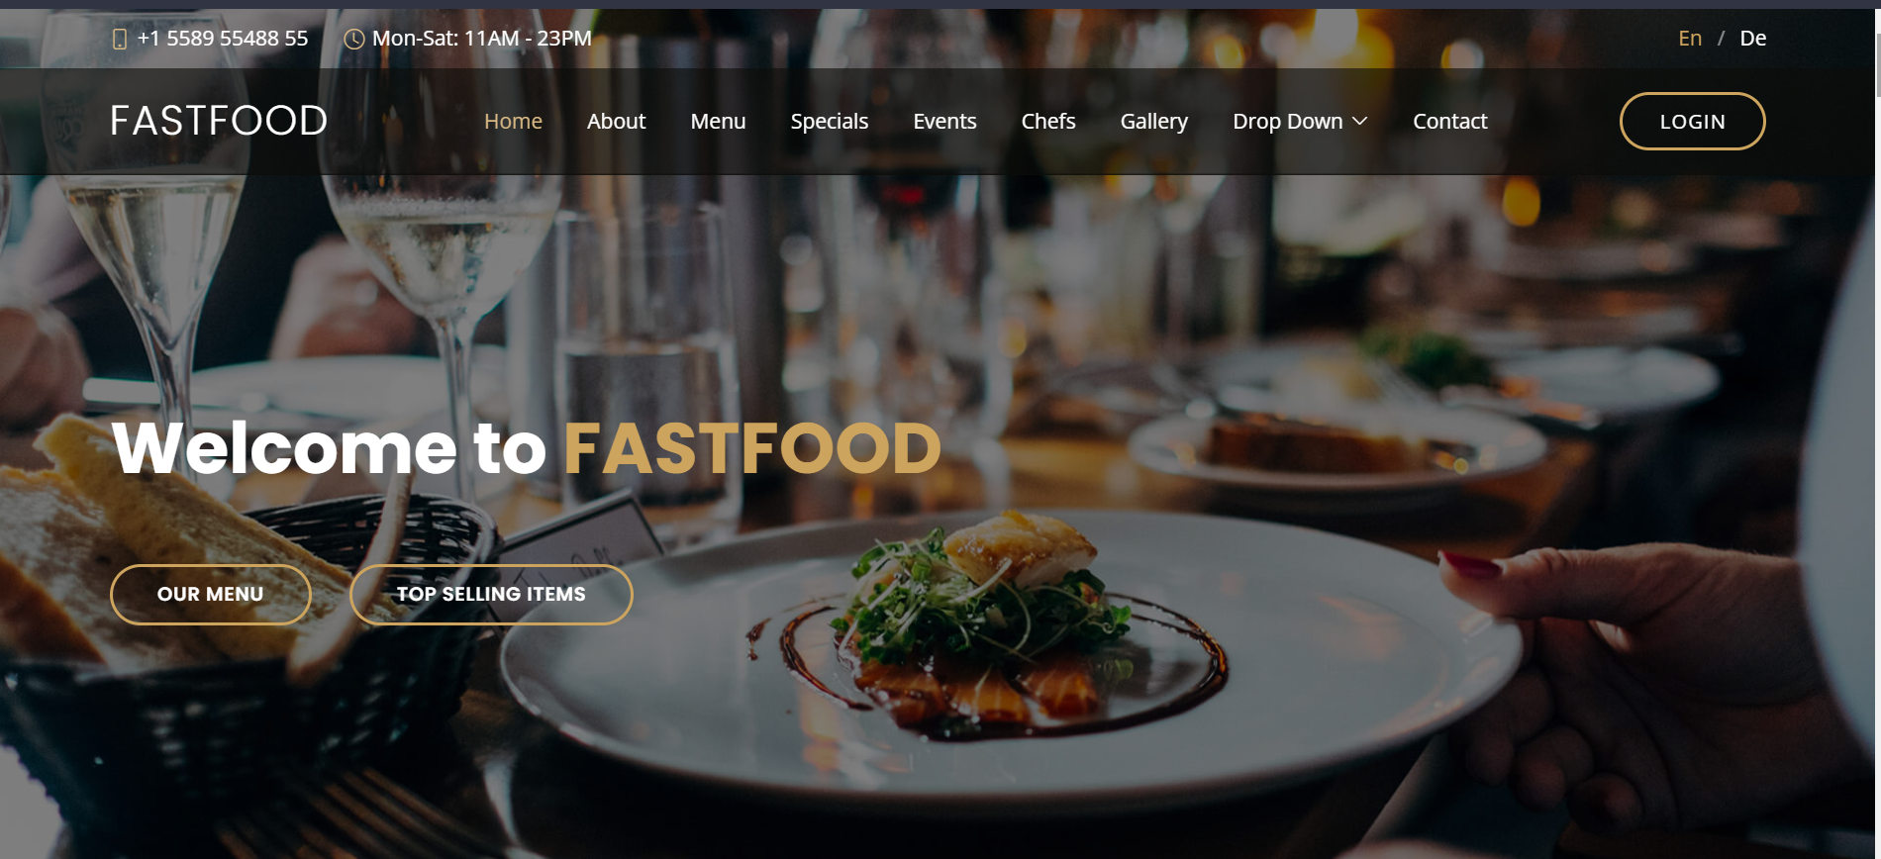

Cart page

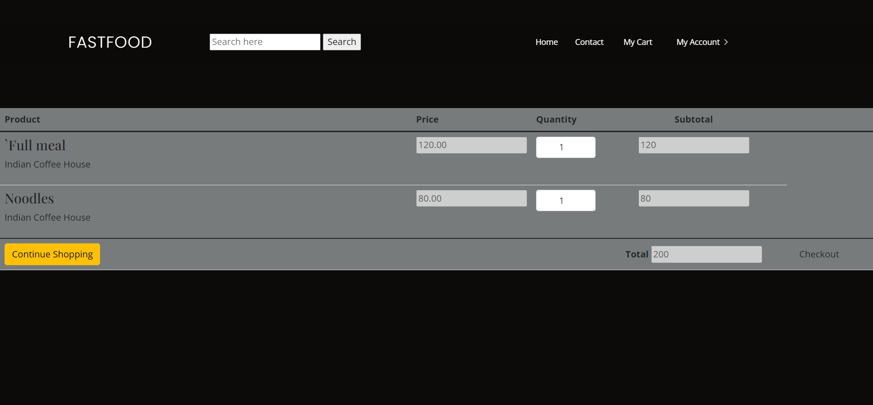

**3.3 TABLE DESCRIPTION**

1. **LOGIN :**

This table contains all user_id of all users and hash of their password. The columns in this table are :

* + 1. user_id : (VARCHAR(10))This is id of all the users present in the system
    2. password_hash : (VARCHAR(256))hash of passwords set by the user

1. **USER :**

This table contains the details of all the users of the system. The table contains following columns :

* + 1. user_id : (VARCHAR(10)) (auto generated) primary key used to identify unique users
    2. user_name :(VARCHAR(50)) name of the user entered by the user while registration
    3. email : (VARCHAR(100))email address of the user entered by the user while registration
    4. phone : (VARCHAR(10)) phone number of the user (optional)
    5. user_role : INT(1) used to identify the user type. The user_role can take 3 values (0 : student, 1 : admin) and the users are redirected to the relevant dashboards based on the user type.

1. **OWNS :**

This table represents the weak entity that can help to identify the owners of all shops. shop_id and admin_id are foreign keys that can help us to find the shops owned by users of type admin. The table contains following columns :

* + 1. admin_id : (VARCHAR(10)) user_id of the admin who owns the shop
    2. shop_id : (VARCHAR(10)) shop_id of the shop

1. **SHOP :**

This table contains details of the shops. It contains following columns

* + 1. shop_id : (VARCHAR(10) (auto-generated) unique id assigned to each shop while it is created by the admins
    2. shop_name : (VARCHAR(50)) name of the shop given by the admins during registration
    3. shop_description : (VARCHAR(100)) (optional) short description of the shop
    4. location : location of the shop set by the admin during registration.

1. **ORDERS:**

This table contains the orders created by the users of type student. It contains following columns :

* + 1. order_id : (VARCHAR(10) (auto-generated) unique id to identify each orders
    2. user_id : (VARCHAR(10) user_id of the student who creates the order
    3. order_status : INT(1) status of the order which can be modified by any of the users. It can take 4 values (new : 0, canceled : 1 , processing : 2 , complete : 3). Initially it is set to value ‘new’. Users of type students can only change the status to canceled and admins or chefs can change it. The change is allowed only according to the order of the values as given above. The status can not be rolled back to a state before it in the list. (for example, an order that is processing can not be changed to canceled or an order that is complete can not be changed to new).
    4. notes : (VARCHAR(10)) (optional)special delivery notes given by the user
    5. order_date : (DATE) date of the creation of order
    6. order_time : (TIME) time of creation of the order
    7. delivery_date : (DATE) date of the requested delivery
    8. delivery_time : (TIME) time of requested delivery
    9. payment_id : (VARCHAR(10)) a new entry is created in the payment table with details of the order. The user needs to complete the payment before set time in order to avoid change in status to ‘canceled’.

1. **ORDER_ITEMS :**

This table maps the food_items with order_id, this helps us identify the food_items in a single order. It is a weak entity and item_id and order_id are foreign keys used. It contains following columns:

* + 1. item_id : (VARCHAR(10) item_id of the food item
    2. order_id : (VARCHAR(10) order_id of the order which contains the food item.

1. **PAYMENTS :**

This table contains all the payment details with their status. It contains following columns :

* + 1. payment_id : (VARCHAR(10) (auto-generated) unique id to identify unique payments.
    2. user_id : (VARCHAR(10) user_id of the user who makes (or is required to make) the payment
    3. shop_id : (VARCHAR(10) shop_id is the id of the shop to which the payment is made.
    4. amount : INT(3) the bill amount that is should be paid
    5. status : INT(1) status of the payment. (0 : pending, 1 : progress, 2 : complete, -1 : failed)
    6. order_id : (VARCHAR(10) to identify the order associated with the payment.

1. **FOOD_ITEMS :**

This table contains the information about various food items provided by the shops. It contains following columns :

* + 1. item_id : (VARCHAR(10) (auto-generated) unique id to identify each item
    2. shop_id : (VARCHAR(10) shop_id of the shop that provides the item
    3. price : INT(3) cost of the item
    4. name : (VARCHAR(10) name of the item
    5. status : INT(1) availability status of the item (0 : unavailable, 1 : available)
    6. category : (VARCHAR(10) category of the food the item belongs to.

1. **OFF_DAYS :**

This table is used to determine when a given shop is closed. It contains details of opening and closing timings of a given shop. It is a weak entity and contains following column :

* + 1. shop_id : (VARCHAR(10) shop_id of the shop of which the details are about
    2. date : (DATE) date of the day when the shop is closed
    3. start_time : (TIME) start time of the closing of the shop (closing time)
    4. end_time : (TIME) end of the closing of shop (opening time)

**CHAPTER 4**

**CONSTRUCTION**

**4.1 Software and Hardware Environments**

**Software**

|  |  |  |
| --- | --- | --- |
| **Name Of Components** | **Framework** | **Reasons for choosing** |
| Front end design | Bootstrap, HTML, CSS, JavaScript | Availability of templates and ease of making responsive design. |
| Server | Django | Dynamic database queries that are secure from SQL injection attacks.  Availability of material to learn.  Ease of development. |
| Database | MySql | Faster performance |
| Browser | Brave, Edge, Chrome | Any browser can be used. |
| IDE | VS Code | Availability of extensions, Keyboard shortcuts. |
| Version Control | GitHub | Convenience of maintaining a shared repository to contribute to the project and sync the progress across systems of all team members.  Back up of code in case of accidental deletions from local machines. |

**HARDWARE**

|  |  |
| --- | --- |
| **Name Of Components** | **Specification** |
| Processor | Ryzen 5 3550 |
| RAM | 8GB |
| HardDisk | 1TB |

**CHAPTER 5**

**TESTING**

**TEST CASES**

**/\***

**Requirements:**

**1. Index Page**

**2. Login IN and Sign Up.**

**3. Dashboard**

**4. Cart**

**5. Place Order**

**6. Payment**

**7. Security**

**\*/**

**Test Cases**

|  |  |  |  |  |  |  |
| --- | --- | --- | --- | --- | --- | --- |
| **Test ID** | **Test Name** | **Description** | **Req ID** | **Procedure** | **Expected O/P** | **Result** |
| **1.1** | **Check any one Can visit this site .** | **To ensure that anyone can go this page without any restriction.** | **1** | **1 Just Click on the link.** | **1. login should be enabled**  **2. Able to login/Sign Up.** | **Pass** |
| **2.1** | **Check If User has Own ID and Password are Correct or not.** | **To check User Name and Password are valid Or not, it is fetched from the Database provided.** | **2** | **2.1.1) First Go to the Main page.**  **2.1.2) Click on Login Button and fill the user name and Password after then click login.** | **1.Dashboard Must Be Open.**  **According To User Perspective.** | **Pass** |
| **2.2** | **Check If User has no user name and Password.** | **If User has no User Name and Password Then it Sign Up/Register yourself.** | **2** | **2.2.1) First Go to the Main page.**  **2.2.2) Click on Login Button and then Register Bottom then Fill all required details then click signup.** | **1.The Data Must be saved On the Server.**  **2. Users are able to login next time with the same username and password.** | **Pass** |
| **2.3** | **Check The Given Sign Up page works Properly.** | **To check if**  **error message shows if an empty text box and type Incorrect format.** | **2** | **2.3.1) When In sign Up page type anything it gives error**  **2.3.2) check if it displays empty file error message** | **1.It shows Error message After entering any wrong Information or Not in Required Format.** | **Pass** |
| **2.4** | **Check login without valid credentials** | **Type invalid credentials (username and/or password) in the fields** | **2** | **2.4.1) Open login page**  **2.4.2) Enter invalid credentials in all combinations**  **2.4.3) Click on login** | **The user should be displayed login page with the appropriate error message based on the invalid inputs provided** | **Pass** |
| **3.1** | **After Verifying, the User Dashboard must be open.** | **Check Dashboard page Open or not.** | **3** | **3.1.1 After Login**  **Dashboard page Should be Open.** | **1. After Successfully**  **Dashboard page Should be Open and user should perform operation.** | **Pass** |
| **3.2** | **Check if food items are displayed in homepage for the user** | **Check User Must be able to see all the food items and shop with their details.** | **3** | **3.2.1 visit the site, login with valid credentials** | **1. User should be redirected to homepage with food items and shops** | **Pass** |
| **3.3** | **Check User Is able to Add to cart selected Food items.** | **Check if the User can add multiple items into the cart** | **3** | **3.3.1) Login with valid credentials. In user Dashboard page click on “add to cart” button** | **1. Items should be added to cart cookie** | **Pass** |
| **4.2** | **Check if increasing or decreasing quantity of food items is working** | **To check if the subtotal and final total are dynamically changing on changing quantity of the items** | **4** | **4.2.1) Login with valid credentials. Add items to cart. Click on “MyCart” button in top navigation bar. After being redirected to cart page, increase or decrease the quantity** | **User should be able to see the change in total sum and the subtotal for each selected item** | **Pass** |
| **5.1** | **Check if the able to continue after the add to cart.** | **Check user is able to proceed next after selecting all the item in the add to cart page. With the cart Item cookie set to a 2d array with item_id and quantity** | **5** | **5.1.1) Login with valid credentials,**  **5.1.2) add items to cart, 5.1.3) click on mycart**  **5.1.4)click on proceed button** | **User is redirected to delivery details page and the cartItem cookie is set** | **Pass** |
| **5.2** | **Check If all the Filed is Working on address form is not.** | **Check If all the Filed is Working on address form is not.** | **5** | **5.2.1) When We in place holder page it should provide all the required details .** | **Able to save all details and proceed to payment.** | **Pass** |
| **5.3** | **Check If any filed is not filled.** | **Check if user will not fill any field accidently then we can't able to proceed further.** | **5** | **5.3.1)It must sure that all field must be filled before proceeding further.** | **Able to go Payment page.** | **Pass** |
| **6.1** | **Check User is able to transaction.** | **Check If user want to order then it must fill the transaction details or card.** | **6** | **6.1.1)When we click proceed to payment then must fill all required details.** | **User can see the payment page able to proceed transaction.** | **Pass** |
| **6.2** | **Check user is able to payment from multiple method.** | **Check the user is able to payment from different method such UPI, card and Paytm .. etc.** | **6** | **6.2.1)In the Payment page user have multiple option for payment.** | **User can able to choose any option for transaction.** | **Fail** |
| **6.3** | **Check for notification.** | **Check after the transaction successfully shop management and user both will see the notification.** | **6** | **6.3.1)When we click on payment after fill details.** | **User and Shop management are able to see your order details.** | **Fail** |
| **7.1** | **Check all valid pages loading without logging in** | **Try to open following urls without logging in :**  **/register.html**  **/login.html**  **/userdash**  **/index.html**  **/cart.html**  **/placeorder.html**  **/showorders.html** | **7** | **7.1.1)Type the host name followed by the urls** | **User should only be able to access index.html, login.html,**  **Register.html without logging in** | **Pass** |
| **7.2** | **Check pages loading after successful login** | **Try to open following urls after logging in :**  **/register.html**  **/login.html**  **/userdash.html**  **/index.html**  **/cart.html**  **/placeorder.html**  **/showorders.html** | **7** | **7.2.1)Login with valid credentials and type the host name followed by the urls** | **User should be redirected to userdash.html on trying to access login.html, index.html or register.html**  **All other pages should load with appropriate data** | **Pass** |
| **7.3** | **Check loading urls with post requests** | **Try to open following urls with or without logging in**  **/register**  **/login**  **/place order** | **7** | **7.3.1)Type hostname followed by given urls.** | **User should be redirected to index.html** | **Pass** |

**5.2 Module Integration plan:**

Since version control tool github was used throughout the process of development, all the team members were able to access and modify the same repository at the same time. The repository is published on github and can be accessed with the link : <https://github.com/Adhokshaja73/Fast-Food>

**5.3 Defects:**

|  |  |  |
| --- | --- | --- |
| **Title** | **Defect** | **Reason/Fix** |
| Chef Module | Chef module was discarded and Shop Admin gets the orders in their dashboard instead of a separate chef module | Due to time constraints we were not able to design the UI and workflow of chefs. The Module is integrated within the shop admin module resulting in a system where a single shop admin has to manage a single shop which initially was a “one to many” relation. This can be easily implemented in future releases. |
| Payment Gateway | Payment gateway integration was not done. Instead the user is shown a dummy payment page. | Integration with a third party payment gateway which allowed users to pay for the food beforehand was a required feature. But we were not able to implement it due to lack of |

**CHAPTER 6**

**(Screen shots)**

**6.1 Index page**



**6.2 LoginPage**

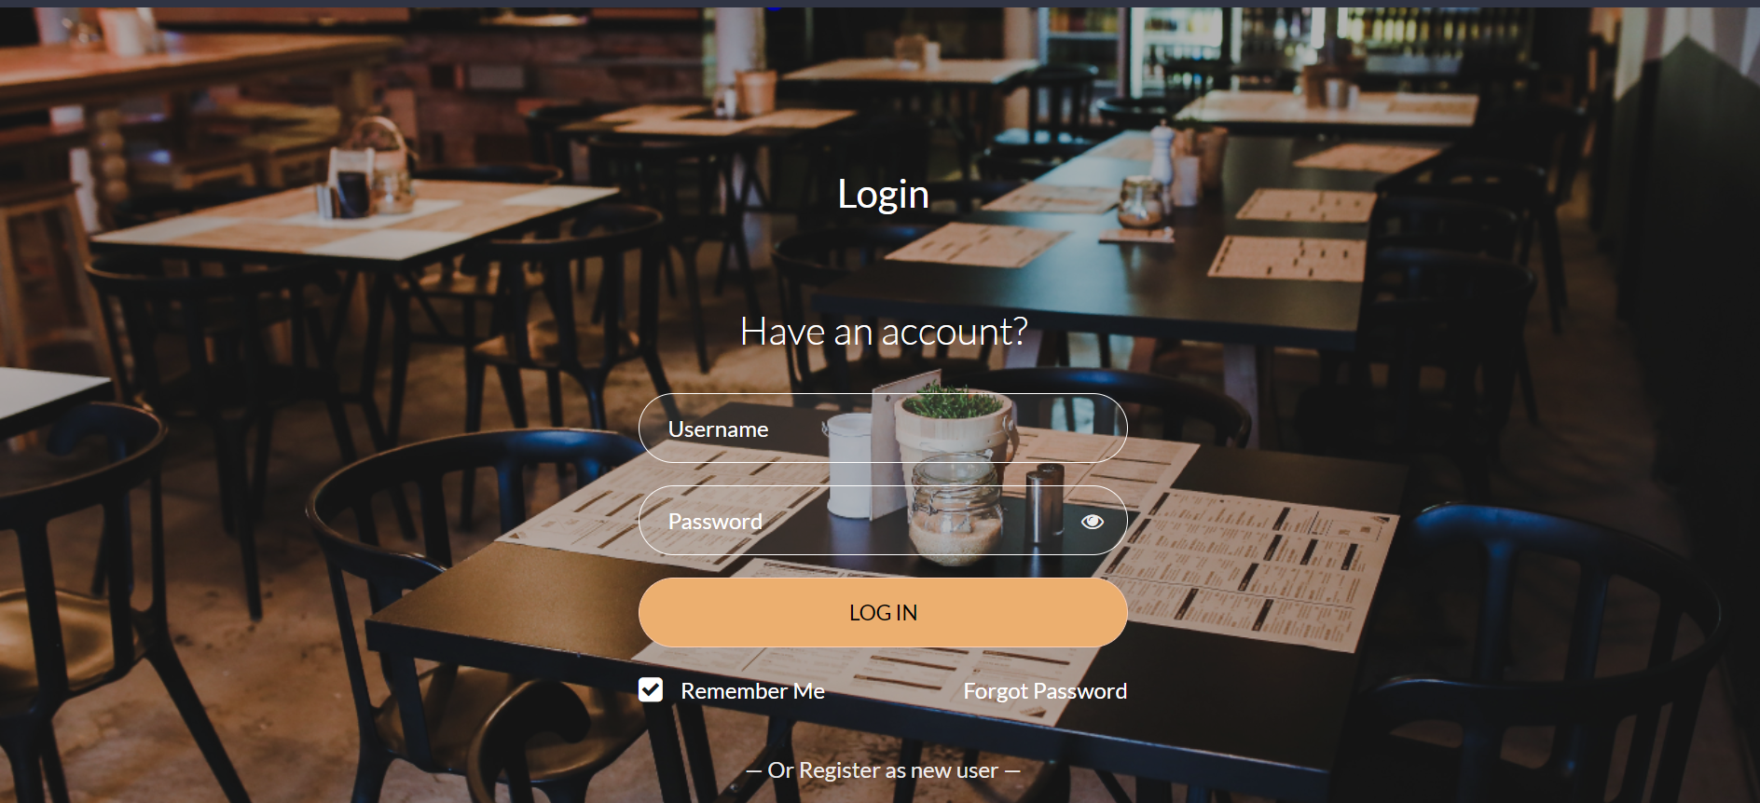

**6.3 Registration Page**

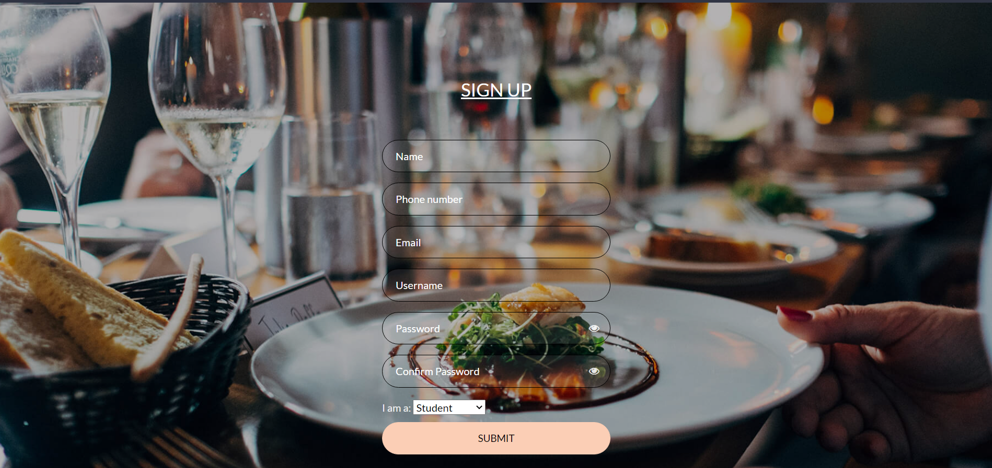

**6.4.1 User Home page**

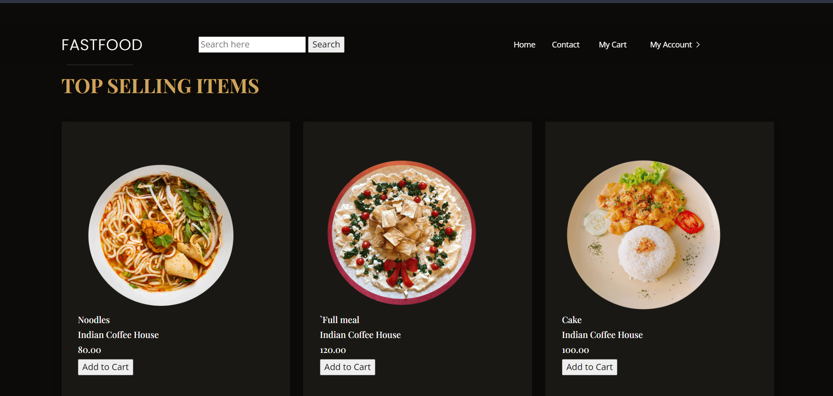

**6.4.2 Cart Page**



**6.4.3 Delivery Details Page**

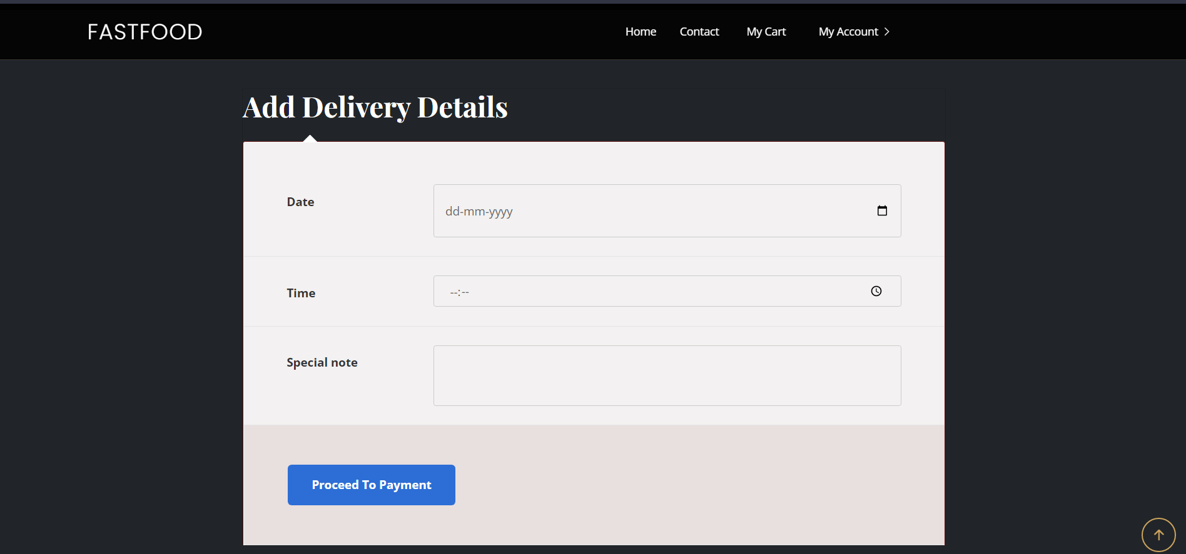

**6.4.4 Payment Page**

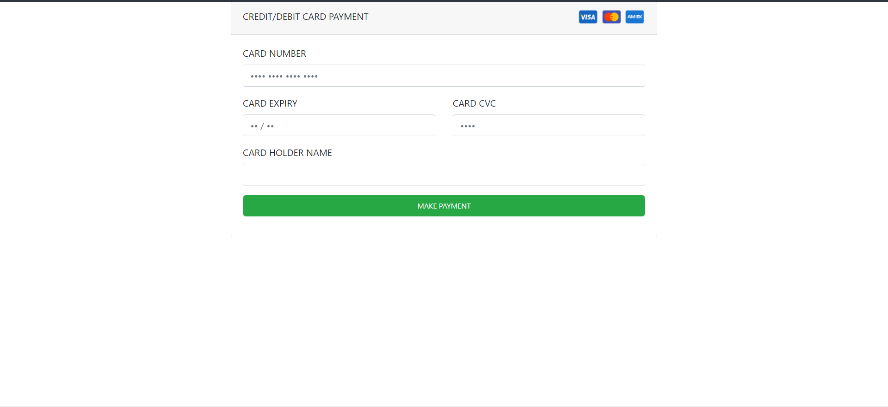

**6.5.1 Admin Home Page**

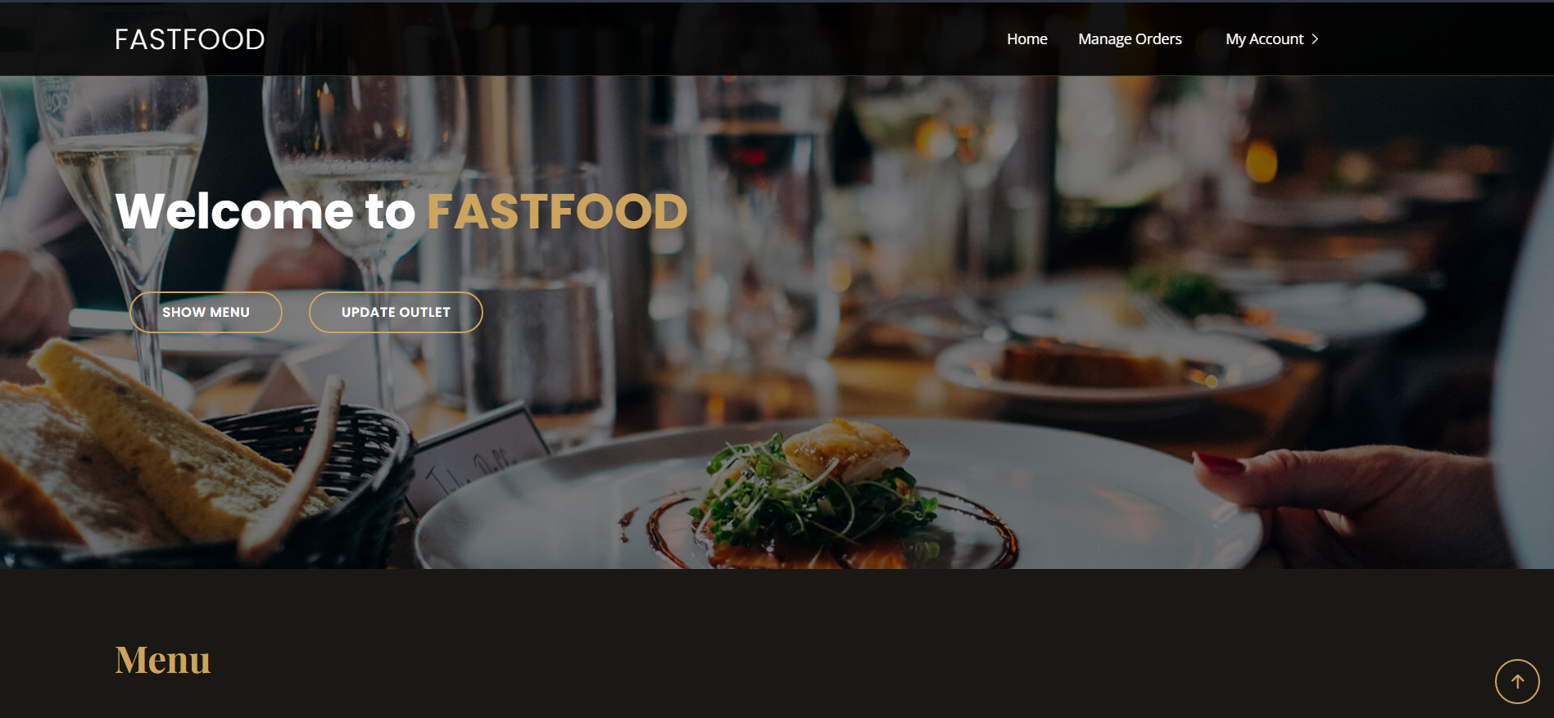

**6.5.2 Add new item**

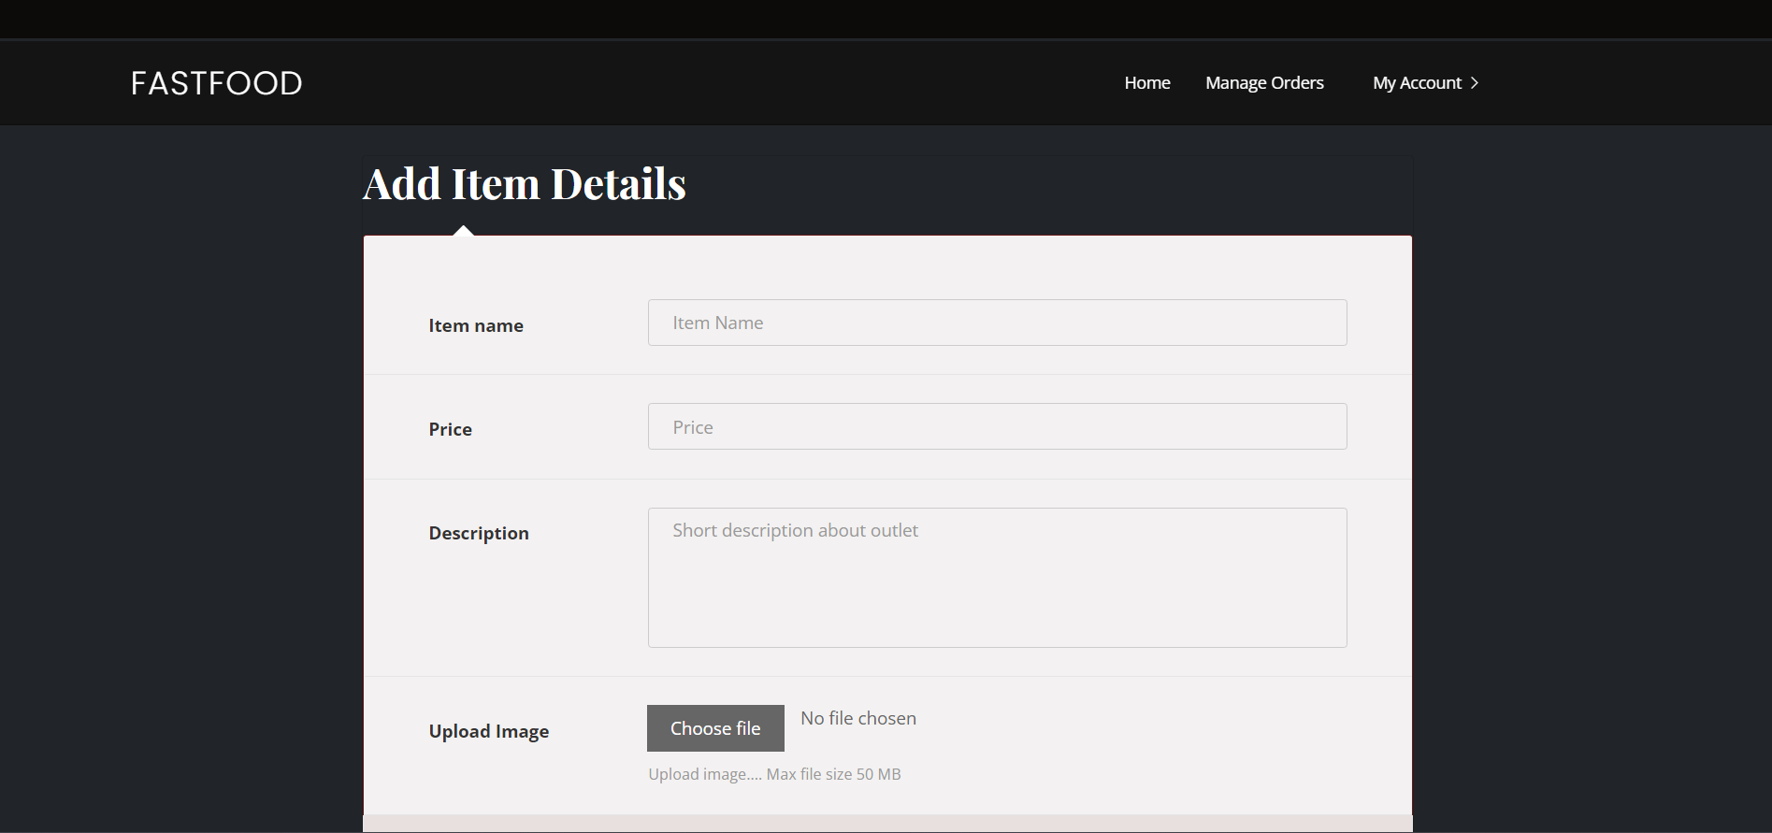

**6.5.3 Add new outlet**

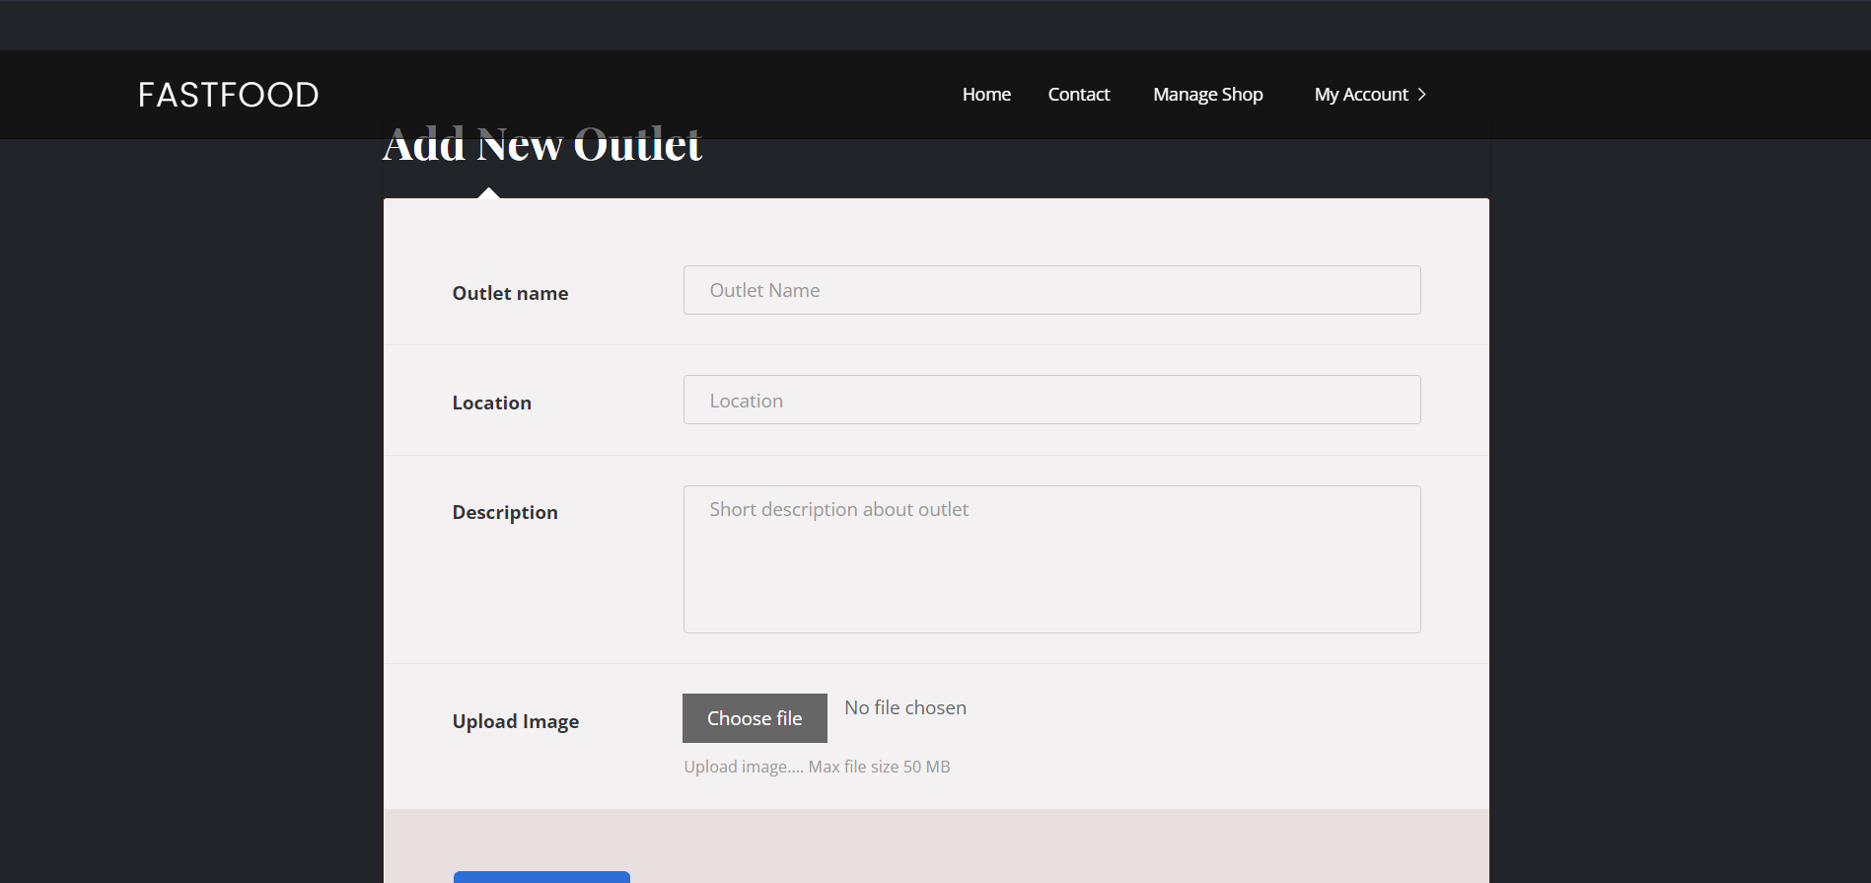

**CODE OF THE PROJECT**

**FAST-FOOD**

**INDEX.html**

<!DOCTYPE html>

<html lang="en">

{% load static %} {% static "assets/food_images" as food_image%}

<head>

<meta charset="utf-8">

<meta content="width=device-width, initial-scale=1.0" name="viewport">

<meta content="" name="description">

<meta content="" name="keywords">

<link href="https://fonts.googleapis.com/css?family=Open+Sans:300,300i,400,400i,600,600i,700,700i|Playfair+Display:ital,wght@0,400;0,500;0,600;0,700;1,400;1,500;1,600;1,700|Poppins:300,300i,400,400i,500,500i,600,600i,700,700i" rel="stylesheet">

<link href="{% static 'assets/img/favicon.png' %}" rel="icon">

<link href="{% static 'assets/img/apple-touch-icon.png' %}" rel="apple-touch-icon">

<link href="{% static 'assets/vendor/animate.css/animate.min.css' %}" rel="stylesheet">

<link href="{% static 'assets/vendor/aos/aos.css' %}" rel="stylesheet">

<link href="{% static 'assets/vendor/bootstrap/css/bootstrap.min.css' %}" rel="stylesheet">

<link href="{% static 'assets/vendor/bootstrap-icons/bootstrap-icons.css' %}" rel="stylesheet">

<link href="{% static 'assets/vendor/boxicons/css/boxicons.min.css' %}" rel="stylesheet">

<link href="{% static 'assets/vendor/glightbox/css/glightbox.min.css' %}" rel="stylesheet">

<link href="{% static 'assets/vendor/swiper/swiper-bundle.min.css' %}" rel="stylesheet>

<link href="{% static 'assets/css/style.css' %}" rel="stylesheet">

</head>

<body>

<div id="topbar" class="d-flex align-items-center fixed-top">

<div class="container d-flex justify-content-center justify-content-md-between">

</div>

</div>

<header id="header" class="fixed-top d-flex align-items-cente">

<div class="container-fluid container-xl d-flex align-items-center justify-content-lg-between">

<h1 class="logo me-auto me-lg-0"><a href="index.html">FASTFOOD</a></h1>

<!-- Uncomment below if you prefer to use an image logo -->

<!-- <a href="index.html" class="logo me-auto me-lg-0"><img src="assets/img/logo.png" alt="" class="img-fluid"></a>-->

<nav id="navbar" class="navbar order-last order-lg-0">

<ul>

<pre> </pre>

<li><a class="nav-link scrollto active" href="#hero">Home</a></li>

<li><a class="nav-link scrollto" href="#menu">Menu</a></li>

<li><a class="nav-link scrollto" href="#contact">Contact</a></li>

</ul>

</nav>

<i class="bi bi-list mobile-nav-toggle"></i>

<a href="login.html" class="book-a-table-btn scrollto d-none d-lg-flex">LOGIN</a>

</header>

<section id="hero" class="d-flex align-items-center">

<div class="container position-relative text-center text-lg-start" data-aos="zoom-in" data-aos-delay="100">

<div class="row">

<div class="col-lg-8">

<h1>Welcome to <span>FASTFOOD</span>

<div class="btns">

<a href="#menu" class="btn-book animated fadeInUp scrollto">Menu</a>

<a href="#Top-selling" class="btn-book animated fadeInUp scrollto">Top Selling Items</a>

</div>

</div>

</div>

</div>

</section>

<main id="main">

<section id="Top-selling" class="why-us">

<div class="container" data-aos="fade-up">

<div class="section-title">

<h2></h2>

<p>TOP SELLING ITEMS</p>

</div>

<div class="row">

{% for item in topItems%}

<div class="col-lg-4">

<div class="box" data-aos="zoom-in" data-aos-delay="100">

<img src="{{food_image}}/{{item.image_url}}" height="300" width="300" class="menu-img">

<h6>{{item.name}}</h6>

<h6>{{item.price }}</h6>

<h6>{{item.shop.shop_name}}</h6>

<a href="book.html" class="book-a-table-btn scrollto d-none d-lg-flex">ORDER NOW</a>

<p></p>

</div>

</div>

{% endfor %}

</div>

</div>

</section>

<section id="menu" class="menu section-bg">

<div class="container" data-aos="fade-up">

<div class="section-title">

<p>Menu</p>

</div>

<div class="row" data-aos="fade-up" data-aos-delay="100">

<div class="col-lg-12 d-flex justify-content-center">

<ul id="menu-flters">

<li data-filter="*" class="filter-active">All</li>

<li data-filter=".filter-starters">Category1</li>

<li data-filter=".filter-salads">Category2</li>

<li data-filter=".filter-specialty">Category3</li>

</ul>

</div>

</div>

<div class="row menu-container" data-aos="fade-up" data-aos-delay="200">

<div class="col-lg-6 menu-item filter-starters">

<img src="{% static 'assets/img/menu/lobster-bisque.jpg' %}" class="menu-img" alt="">

<div class="menu-content">

<a href="#">Lobster Bisque</a><span>$5.95</span>

</div>

<div class="menu-ingredients">

Lorem, deren, trataro, filede, nerada

</div>

</div>

</div>

</div>

</section>

</main>

<div id="preloader"></div>

<a href="#" class="back-to-top d-flex align-items-center justify-content-center"><i class="bi bi-arrow-up-short"></i></a>

<script src="{% static 'assets/vendor/aos/aos.js' %}"></script>

<script src="{% static 'assets/vendor/bootstrap/js/bootstrap.bundle.min.js' %}"></script>

<script src="{% static 'assets/vendor/glightbox/js/glightbox.min.js' %}"></script>

<script src="{% static 'assets/vendor/isotope-layout/isotope.pkgd.min.js' %}"></script>

<script src="{% static 'assets/vendor/swiper/swiper-bundle.min.js' %}"></script>

<script src="{% static 'assets/vendor/php-email-form/validate.js' %}"></script>

<script src="{% static 'assets/js/main.js' %}"></script>

</body>

</html>

**7.2 Userdash.html**

<!DOCTYPE html>

<html lang="en">

{% load static %} {% static "../media" as food_image%}

<head>

    <meta charset="utf-8">

    <meta content="width=device-width, initial-scale=1.0" name="viewport">

    <title>Restaurantly Bootstrap Template - Index</title>

    <meta content="" name="description">

    <meta content="" name="keywords">

    <!-- Google Fonts -->

    <link

        href="https://fonts.googleapis.com/css?family=Open+Sans:300,300i,400,400i,600,600i,700,700i|Playfair+Display:ital,wght@0,400;0,500;0,600;0,700;1,400;1,500;1,600;1,700|Poppins:300,300i,400,400i,500,500i,600,600i,700,700i"

        rel="stylesheet">

    <!-- Vendor CSS Files -->

    <!-- Favicons -->

    <link href="{% static 'assets/img/favicon.png' %}" rel="icon">

    <link href="{% static 'assets/img/apple-touch-icon.png' %}" rel="apple-touch-icon">

    <link href="{% static 'assets/vendor/animate.css/animate.min.css' %}" rel="stylesheet">

    <link href="{% static 'assets/vendor/aos/aos.css' %}" rel="stylesheet">

    <link href="{% static 'assets/vendor/bootstrap/css/bootstrap.min.css' %}" rel="stylesheet">

    <link href="{% static 'assets/vendor/bootstrap-icons/bootstrap-icons.css' %}" rel="stylesheet">

    <link href="{% static 'assets/vendor/boxicons/css/boxicons.min.css' %}" rel="stylesheet">

    <link href="{% static 'assets/vendor/glightbox/css/glightbox.min.css' %}" rel="stylesheet">

    <link href="{% static 'assets/vendor/swiper/swiper-bundle.min.css' %}" rel="stylesheet">

    <link href="{% static 'assets/css/style.css' %}" rel="stylesheet">

    <link href="{% static 'assets/css/sweetalert.css' %}" rel="stylesheet">

    <script src="https://unpkg.com/sweetalert/dist/sweetalert.min.js"></script>

    <!-- =======================================================

  * Template Name: Restaurantly - v3.7.0

  * Template URL: https://bootstrapmade.com/restaurantly-restaurant-template/

  * Author: BootstrapMade.com

  * License: https://bootstrapmade.com/license/

  ======================================================== -->

</head>

<body onload="deleteCookie('cart'); deleteCookie('selectedShop'); deleteCookie('cartMap')">

    <!-- ======= Top Bar ======= -->

    <div id="topbar" class="d-flex align-items-center fixed-top">

        <div class="container d-flex justify-content-center justify-content-md-between">

        </div>

    </div>

    <!-- ======= Header ======= -->

    <header id="header" class="fixed-top d-flex align-items-cente">

        <div class="container-fluid container-xl d-flex align-items-center justify-content-lg-between">

            <h1 class="logo me-auto me-lg-0"><a href="">FASTFOOD</a></h1>

            <!-- Uncomment below if you prefer to use an image logo -->

            <!-- <a href="index.html" class="logo me-auto me-lg-0"><img src="assets/img/logo.png" alt="" class="img-fluid"></a>-->

            <nav id="navbar" class="navbar order-last order-lg-0">

                <ul>

                    <li>

                        <form action="" method="post">

                            <input type="search" name="search" placeholder="Search here">

                            <input type="button" style="box-shadow: inset;" value="Search">

                        </form>

                    </li>

                    <pre>                                    </pre>

                    <li><a class="nav-link scrollto" href="userdash.html">Home</a></li>

                    <li><a href="#"><span>Contact</span> <i></i></a></li>

                    <li>

                    <li><a href="cart.html"><span>My Cart</span> <i></i></a></li>

                    <pre> </pre>

                    </li>

                    <li>

                        <ul>

                            <li class="dropdown"><a href="#"><span>My Account</span> <i

                                        class="bi bi-chevron-right"></i></a>

                                <ul>

                                    <li><a href="profile.html">My profile</a></li>

                                    <li><a href="my_order">My Orders</a></li>

                                    <li><a href="logout"><button class="book-a-table-btn scrollto d-none d-lg-flex" style="background-color: rgb(13, 13, 21);">LOGOUT</button></a></li>

                                </ul>

                            </li>

                        </ul>

                    </li>

                </ul>

                <i class="bi bi-list mobile-nav-toggle"></i>

            </nav>

            <!-- .navbar -->

            <ul>

            </ul>

        </div>

    </header>

    <!-- End Header -->

    </header>

    <!-- End Header -->

    <br>

    <br>

    <br>

    <br>

    <main id="main">

        <!-- ======= top selling ======= -->

        <section id="Top-selling" class="why-us">

            <div class="container">

                <div class="section-title">

                    <h2></h2>

                    <p>TOP SELLING ITEMS</p>

                </div>

                <div class="row">

                    {% for item in foodItems%}

                    <div class="col-lg-4">

                        <div class="box">

                            <img src="{{food_image}}/{{item.image}}" height="300" width="300" class="menu-img">

                            <h6>{{ item.name }}</h6>

                            <h6>{{ item.shop.shop_name }}</h6>

                            <h6>{{ item.price }}</h6>

                            <!-- <form action="addToCart('{{ item.item_id }}')" method="post">

                                {% csrf_token %}

                                <input hidden="true" name="item" value="{{ item.item_id }}">

                                <input type="submit" title="Add to cart">

                            </form> -->

                            <input type="button" id="addtocart" onclick="addToCart('{{ item.item_id }}', '{{ item.shop.shop_id }}')"

                                value="Add to Cart">

                            <p></p>

                        </div>

                    </div>

                    {% endfor %}

                    <script>

                        function addToCart(itm, shopId) {

                            //add itm to window.Cookies.cart

                            if (readCookie('selectedShop') == "" || readCookie('selectedShop') == shopId) {

                                saveCookie(shopId)

                                var cart = readCookie("cart")

                                if (cart == "") {

                                    let arr = []

                                    var json_str = JSON.stringify(arr);

                                    document.cookie = "cart=" + json_str;

                                }

                                var json_str = readCookie('cart');

                                var cart = JSON.parse(json_str);

                                cart.push(itm)

                                var json_str = JSON.stringify(cart);

                                document.cookie = "cart=" + json_str;

                                console.log(cart)

                                swal("Item Added to the cart!", "", "success");

                            }

                            else if (readCookie('selectedShop') != shopId) {

                                swal("Select items from only one shop. Refresh page to change selected shop","", "error");

                            }

                                //let text = "Item added to cart";

                                //if (confirm(text) == true) {

                                //    location.href="http://127.0.0.1:8000/cart.html"

                                //} else {

                                //    document.getElementById("addtocart").disabled = true;

                                //}

                        }

                        function saveCookie(shopName) {

                            document.cookie = "selectedShop=" + shopName

                        }

                        function readCookie(cname) {

                            let name = cname + "=";

                            let decodedCookie = decodeURIComponent(document.cookie);

                            let ca = decodedCookie.split(';');

                            for (let i = 0; i < ca.length; i++) {

                                let c = ca[i];

                                while (c.charAt(0) == ' ') {

                                    c = c.substring(1);

                                }

                                if (c.indexOf(name) == 0) {

                                    return c.substring(name.length, c.length);

                                }

                            }

                            return "";

                        }

                        function deleteCookie(name) {

                            document.cookie = name + '=; Path=/; Expires=Thu, 01 Jan 1970 00:00:01 GMT;';

                        }

                    </script>

                </div>

            </div>

        </section>

        <!-- top selling Section -->

    </main>

    <!-- End #main -->

    <!-- ======= Footer ======= -->

    <footer id="footer">

        <div class="footer-top">

            <div class="container">

                <div class="row">

                    <div class="col-lg-3 col-md-6">

                        <div class="footer-info">

                            <h3>FASTFOOD</h3>

                            <p>

                                Christ University Central Campus <br> Bengaluru

                                <br><br>

                                <strong>Phone:</strong> +91 9188578700<br>

                                <strong>Email:</strong> info@example.com<br>

                                <a href="">Contact US</a>

                            </p>

                            <div class="social-links mt-3">

                                <a href="#" class="twitter"><i class="bx bxl-twitter"></i></a>

                                <a href="#" class="facebook"><i class="bx bxl-facebook"></i></a>

                                <a href="#" class="instagram"><i class="bx bxl-instagram"></i></a>

                                <a href="#" class="google-plus"><i class="bx bxl-skype"></i></a>

                                <a href="#" class="linkedin"><i class="bx bxl-linkedin"></i></a>

                            </div>

                        </div>

                    </div>

                </div>

            </div>

        </div>

    </footer>

    <!-- End Footer -->

    <div id="preloader"></div>

    <a href="#" class="back-to-top d-flex align-items-center justify-content-center"><i

            class="bi bi-arrow-up-short"></i></a>

    <!-- Vendor JS Files -->

    <script src="{% static 'assets/vendor/aos/aos.js' %}"></script>

    <script src="{% static 'assets/vendor/bootstrap/js/bootstrap.bundle.min.js' %}"></script>

    <script src="{% static 'assets/vendor/glightbox/js/glightbox.min.js' %}"></script>

    <script src="{% static 'assets/vendor/isotope-layout/isotope.pkgd.min.js' %}"></script>

    <script src="{% static 'assets/vendor/swiper/swiper-bundle.min.js' %}"></script>

    <script src="{% static 'assets/vendor/php-email-form/validate.js' %}"></script>

    <script src="{% static 'assets/js/main.js' %}"></script>

</body>

</html>

**7.3 cart.html**

<!DOCTYPE html>

<html lang="en">

{% load static %}

<head>

    <meta charset="utf-8">

    <meta content="width=device-width, initial-scale=1.0" name="viewport">

    <title>Restaurantly Bootstrap Template - Index</title>

    <meta content="" name="description">

    <meta content="" name="keywords">

    <!-- Favicons -->

    <!-- Google Fonts -->

    <link href="https://fonts.googleapis.com/css?family=Open+Sans:300,300i,400,400i,600,600i,700,700i|Playfair+Display:ital,wght@0,400;0,500;0,600;0,700;1,400;1,500;1,600;1,700|Poppins:300,300i,400,400i,500,500i,600,600i,700,700i" rel="stylesheet">

    <!-- Vendor CSS Files -->

    <link href="{% static 'assets/img/favicon.png' %}" rel="icon">

    <link href="{% static 'assets/img/apple-touch-icon.png' %}" rel="apple-touch-icon">

    <link href="{% static 'assets/vendor/animate.css/animate.min.css' %}" rel="stylesheet">

    <link href="{% static 'assets/vendor/aos/aos.css' %}" rel="stylesheet">

    <link href="{% static 'assets/vendor/bootstrap/css/bootstrap.min.css' %}" rel="stylesheet">

    <link href="{% static 'assets/vendor/bootstrap-icons/bootstrap-icons.css' %}" rel="stylesheet">

    <link href="{% static 'assets/vendor/boxicons/css/boxicons.min.css' %}" rel="stylesheet">

    <link href="{% static 'assets/vendor/glightbox/css/glightbox.min.css' %}" rel="stylesheet">

    <link href="{% static 'assets/vendor/swiper/swiper-bundle.min.css' %}" rel="stylesheet">

    <link href="{% static 'assets/css/style.css' %}" rel="stylesheet">

    <!-- =======================================================

  * Template Name: Restaurantly - v3.7.0

  * Template URL: https://bootstrapmade.com/restaurantly-restaurant-template/

  * Author: BootstrapMade.com

  * License: https://bootstrapmade.com/license/

  ======================================================== -->

</head>

<body onload="deleteCookie('cartMap')">

    <!-- ======= Top Bar ======= -->

    <div id="topbar" class="d-flex align-items-center fixed-top">

        <div class="container d-flex justify-content-center justify-content-md-between">

        </div>

    </div>

    <!-- ======= Header ======= -->

    <header id="header" class="fixed-top d-flex align-items-cente">

        <div class="container-fluid container-xl d-flex align-items-center justify-content-lg-between">

            <h1 class="logo me-auto me-lg-0"><a href="userdash.html">FASTFOOD</a></h1>

            <!-- Uncomment below if you prefer to use an image logo -->

            <!-- <a href="index.html" class="logo me-auto me-lg-0"><img src="assets/img/logo.png" alt="" class="img-fluid"></a>-->

            <nav id="navbar" class="navbar order-last order-lg-0">

                <ul>

                    <li>

                        <form action="" method="post">

                            <input type="search" name="search" placeholder="Search here">

                            <input type="button" style="box-shadow: inset;" value="Search">

                        </form>

                    </li>

                    <pre>                                    </pre>

                    <li><a class="nav-link scrollto" href="userdash.html">Home</a></li>

                    <li><a href="#"><span>Contact</span> <i ></i></a></li>

                    <li>

                        <li><a href="cart.html"><span>My Cart</span> <i ></i></a></li>

                        <pre> </pre>

                    </li>

                    <li>

                        <ul>

                            <li class="dropdown"><a href="#"><span>My Account</span> <i class="bi bi-chevron-right"></i></a>

                                <ul>

                                    <li><a href="#">My profile</a></li>

                                    <li><a href="my_order">My Orders</a></li>

                                    <li><a href="logout"><button class="book-a-table-btn scrollto d-none d-lg-flex" style="background-color: rgb(13, 13, 21);">LOGOUT</button></a></li>

                                </ul>

                            </li>

                        </ul>

                    </li>

                </ul>

                <i class="bi bi-list mobile-nav-toggle"></i>

            </nav>

            <!-- .navbar -->

            <ul>

            </ul>

        </div>

    </header>

    <!-- End Header -->

    <br>

    <br>

    <br>

    <br>

    <main id="main">

    </main>

</body>

<br>

<br>

<br>

<br>

<!-- cart-->

{% if msg %}

<h1>Cart is empty</h1>

{% else %}

<div style="background-color: rgb(120, 123, 123);">

    <table id="cart" class="table table-hover table-condensed">

        <thead>

            <tr>

                <th style="width:50%">Product</th>

                <th style="width:10%">Price</th>

                <th style="width:8%">Quantity</th>

                <th style="width:22%" class="text-center">Subtotal</th>

                <th style="width:10%"></th>

            </tr>

        </thead>

        <tbody>

            <form name="form">

                {% with size=foodItem|length %} {% for item in foodItem %}

                <tr>

                    <td data-th="Product">

                        <div class="row">

                            <div class="col-sm-10">

                                <h4 class="nomargin">{{ item.name }}</h4>

                                <p>{{ item.shop.shop_name }}</p>

                                <input hidden="true" name="itm" value="{{ item.item_id }}">

                            </div>

                        </div>

                    </td>

                    <td><input type="text" data-th="Price" name="price" disabled value="{{ item.price }}"></td>

                    <td data-th="Quantity">

                        <input type="number" min="0" oninput="updateCost('{{size}}')" class="form-control text-center" name="quantity" value="1">

                    </td>

                    <td data-th="Subtotal" class="text-center"><input type="text" disabled name="subtotal" value="{{ item.price }}"></td>

                </tr>

                <script>

                </script>

                {% endfor %}

            </form>

        </tbody>

        <tfoot>

            <tr>

                <td><a href="userdash.html" class="btn btn-warning"><i class="fa fa-angle-left"></i> Continue Shopping</a></td>

                <td colspan="2" class="hidden-xs"></td>

                <td class="hidden-xs text-center"><label><strong>Total</strong></label> <input type="text" disabled id="total"></td>

                <td><a class="btn btn-block" href="placeorder.html" onclick="storeCookie('{{ size }}')">Checkout<i class="fa fa-angle-right"></i></a></td>

            </tr>

        </tfoot>

    </table>

    <meta name="sizes" content="{{ size }}">

    <script>

        var total = 0

        function getMeta(metaName) {

            const metas = document.getElementsByTagName('meta');

            for (let i = 0; i < metas.length; i++) {

                if (metas[i].getAttribute('name') === metaName) {

                    return metas[i].getAttribute('content');

                }

            }

            return '';

        }

        size = parseInt(getMeta('sizes'));

        console.log(size)

        for (i = 0; i < size; i++) {

            quantity = document.form.quantity[i].value;

            price = document.form.price[i].value;

            document.form.subtotal[i].value = price * quantity;

            total += price * quantity

        }

        document.getElementById('total').value = total

    </script>

    {% endwith %} {% endif %}

</div>

<script>

    function updateCost(size) {

        var total = 0

        for (i = 0; i < size; i++) {

            quantity = document.form.quantity[i].value;

            price = document.form.price[i].value;

            document.form.subtotal[i].value = price * quantity;

            total += price * quantity

        }

        document.getElementById('total').value = total

    }

    function deleteCookie(name) {

        document.cookie = name + '=; Path=/; Expires=Thu, 01 Jan 1970 00:00:01 GMT;';

    }

    function storeCookie(size) {

        //add itm to window.Cookies.cart

        let arr = []

        var json_str = JSON.stringify(arr);

        document.cookie = "cartMap=" + json_str;

        for (i = 0; i < size; i++) {

            quantity = document.form.quantity[i].value;

            itm = document.form.itm[i].value;

            var newArr = [itm+ ":"+ parseInt(quantity)]

            console.log(newArr)

            var json_str = readCookie("cartMap");

            var cartMap = JSON.parse(json_str);

            cartMap.push(newArr)

            var json_str = JSON.stringify(cartMap);

            document.cookie = "cartMap=" + json_str;

        }

    }

    function readCookie(cname) {

        let name = cname + "=";

        let decodedCookie = decodeURIComponent(document.cookie);

        let ca = decodedCookie.split(';');

        for (let i = 0; i < ca.length; i++) {

            let c = ca[i];

            while (c.charAt(0) == ' ') {

                c = c.substring(1);

            }

            if (c.indexOf(name) == 0) {

                return c.substring(name.length, c.length);

            }

        }

        return "";

    }

</script>

</html>

**7.4 urls.py**

from django.contrib import admin

from django.urls import path, include

from . import views

urlpatterns = [

path('admin/', admin.site.urls),

path('', views.landingPage),

path('login.html', views.loginPage),

path('login', views.login),

path('register.html', views.registrationPage),

path('register', views.register),

path('userdash.html', views.userDash),

path('addToCart', views.addToCart),

path('cart.html', views.showCart),

path('profile.html', views.profile),

path('placeorder.html', views.placeOrderPage),

path('placeOrder', views.placeOrder ),

path('logout', views.logout),

path('addnewshop.html',views.addnewshop),

path('adminshop.html',views.adminshop),

path('showdetail',views.showdetail),

path('shop_profile',views.shop_profile),

path('payment.html',views.paymentPage),

path('make_payment',views.makePayment),

path('my_order',views.my_order),

path('payment',views.payment),

path('additem.html',views.additem),

path('updateitem',views.updateitem),

]

**7.5 MODELS.py**

from django.db import models

from . import *

class User(models.Model):

USER_ROLES = (

(0, "Student"),

(1, "ShopAdmin"),

)

user_id = models.CharField( max_length =256, primary_key=True)

user_name = models.CharField( max_length =50)

email = models.CharField( max_length =100)

phone = models.CharField( max_length =10)

user_role = models.IntegerField(choices= USER_ROLES)

def __str__(self):

return (self.user_id)

class Login(models.Model):

user = models.ForeignKey(User, on_delete=models.CASCADE, primary_key=True)

password_hash = models.CharField( max_length =64)

def __str__(self):

return (self.user.user_id)

class Shop(models.Model):

shop_id = models.CharField( max_length =256, primary_key=True)

location = models.CharField( max_length =10)

shop_name = models.CharField (max_length = 20)

shop_description = models.CharField( max_length =100)

img = models.ImageField(upload_to = "images/shops/")

def __str__(self):

return (self.shop_name)

class Owns(models.Model):

admin = models.ForeignKey(User, on_delete=models.CASCADE)

shop = models.ForeignKey(Shop, on_delete=models.CASCADE)

class Order(models.Model):

ORDER_STATUS = (

(0, "New"),

(1, "Processing"),

(2, "ReadyToServe"),

(3, "Complete"),

(-1, "Cancelled")

)

order_id = models.CharField( max_length =256, primary_key=True)

user = models.ForeignKey(User, on_delete=models.CASCADE)

shop = models.ForeignKey(Shop, on_delete=models.CASCADE)

order_status = models.IntegerField(choices = ORDER_STATUS)

notes = models.CharField( max_length =100)

order_date_time = models.DateTimeField()

delivery_date_time = models.DateTimeField()

def __str__(self):

return (self.order_id)

class Payments(models.Model):

PAYMENT_STATUS = (

(0, "New"),

(1, "Processing"),

(2, "Complete"),

(-1, "Cancelled")

)

payment_id = models.CharField( max_length =256, primary_key=True)

user = models.ForeignKey(User, on_delete=models.CASCADE)

shop = models.ForeignKey(Shop , on_delete=models.CASCADE)

amount = models.DecimalField( max_digits = 6, decimal_places=2)

order = models.ForeignKey(Order, on_delete=models.CASCADE)

status = models.IntegerField(choices=PAYMENT_STATUS)

class FoodItem(models.Model):

AVAILABILITY_STATUS = (

(0, "Available"),

(1, "Unavailable"),

)

item_id = models.CharField( max_length =256, primary_key=True)

shop = models.ForeignKey(Shop, on_delete=models.CASCADE)

price = models.DecimalField(max_digits = 5, decimal_places=2)

name = models.CharField( max_length =50)

status = models.IntegerField(choices=AVAILABILITY_STATUS)

image = models.FileField(upload_to="images/fooditems/")

category = models.CharField( max_length =50)

class OrderItem(models.Model):

order = models.ForeignKey(Order, on_delete=models.CASCADE)

food_item = models.ForeignKey(FoodItem, on_delete=models.CASCADE)

item_count = models.IntegerField()

class OffDays(models.Model):

shop = models.ForeignKey(Shop, on_delete=models.CASCADE)

date = models.DateField()

start= models.TimeField()

end = models.TimeField()

**7.6 Views.py**

from datetime import date, datetime

from unicodedata import category

from django.http import HttpResponse

from django.shortcuts import render, redirect

from hashlib import sha256

from .models import Payments, User

from .forms import *

import razorpay

def landingPage(request):

if('user' in request.session):

return(redirect("userdash.html"))

return(render(request, "index.html"))

def registrationPage(request):

if('user' in request.session):

return(redirect("userdash.html"))

return(render(request, "register.html"))

def register(request):

if('user' in request.session):

return(redirect("userdash.html"))

result = "fail"

if(request.method == "POST"):

name = request.POST["name"]

phone = request.POST["number"]

email = request.POST["email"]

uName = request.POST["userName"]

password = sha256(request.POST["password"].encode('utf-8')).hexdigest()

role = request.POST["role"]

newUser = User(user_name = name, user_id = uName, email = email, phone = phone, user_role = role)

newUser.save()

newLogin = Login.objects.create(user = newUser, password_hash = password)

newLogin.save()

request.session['user'] = uName

print("ROLE = ", role)

if(role == '0'):

return(redirect("userdash.html"))

else:

return(redirect("addnewshop.html"))

return(render(request, "register.html",{'message' : result}))

def loginPage(request):

if('user' in request.session):

return(redirect("userdash.html"))

return(render(request, "login.html"))

def login(request):

if('user' in request.session):

return(redirect("userdash.html"))

loginStatus = "fail"

if(request.method == "POST"):

userName = request.POST["userName"]

password = sha256(request.POST["password"].encode('utf-8')).hexdigest()

if(User.objects.filter(user_id = userName).exists()):

mUser = User.objects.filter(user_id = userName).get()

if(Login.objects.filter(password_hash = password).exists()):

request.session['user'] = mUser.user_id

return(redirect("userdash.html"))

else:

loginStatus = "Wrong password"

else:

loginStatus = "User does not existS"

return(render(request, "login.html",{'message' : loginStatus}))

def logout(request):

if('user' not in request.session):

return(redirect("index.html"))

del request.session['user']

return(redirect('login.html'))

def userDash(request):

if('user' not in request.session):

return(render(request, 'index.html'))

else:

currentUser = User.objects.filter(user_id = request.session['user']).get()

if(currentUser.user_role == 0 ):

foodItems = FoodItem.objects.all()

return(render(request, "userdash.html", { 'foodItems' : foodItems }))

else:

return(redirect("adminshop.html"))

def addToCart(request):

if(request.method == "POST"):

newItm = request.POST['item']

if('cart' not in request.session):

request.session['cart'] = []

if(newItm not in request.session['cart']):

request.session['cart'].append(newItm)

print(request.session['cart'])

return(redirect("userdash.html"))

else:

print("Something wrong")

return(redirect("userdash.html"))

def showCart(request):

if('user' not in request.session):

return(redirect("userdash.html"))

try:

items = request.COOKIES.get('cart')

items = set(items[1:-1].replace("\"",'').split(","))

print(items)

foodItems = []

print(request.COOKIES.get('cart'))

for i in items:

foodItems.append(FoodItem.objects.filter(item_id = i ).get())

print(foodItems)

response = render(request, 'cart.html', { 'foodItem' : foodItems})

return(response)

except Exception as e:

print(e)

return(render(request, 'cart.html', { 'msg' : "Cart is empty"}))

def placeOrderPage(request):

if('user' not in request.session):

return(redirect("userdash.html"))

else:

return(render(request, 'placeorder.html'))

def placeOrder(request):

if('user' not in request.session):

redirect("index.html")

elif( request.method != "POST"):

print("Not post")

redirect("placeorder.html")

else:

cartMap = request.COOKIES.get("cartMap").replace("\"",'')[1:-1]

cartMap = str(cartMap.split(",")).replace('\'','').replace(" ",'')[1:-1].split(",");

print(cartMap)

items = {}

for i in cartMap:

print(i)

curr = i[1:-1].split(":")

items[curr[0]] = int(curr[1])

print(items)

nOrderId = sha256((request.session['user'] + str(datetime.now())).encode('utf-8')).hexdigest()

nUser = User.objects.filter(user_id = request.session['user']).get()

nShop = Shop.objects.filter(shop_id = request.COOKIES.get('selectedShop')).get()

nOrder_status = 0

nNotes = request.POST['notes']

nOrder_date_time = datetime.now()

nDelivery_date_time = request.POST['date']+" "+request.POST['time']

billAmt = 0

newOrder = Order(order_id = nOrderId, user = nUser, shop = nShop, order_status = nOrder_status, notes = nNotes, order_date_time = nOrder_date_time, delivery_date_time = nDelivery_date_time)

newOrder.save()

for i in items:

orderItem = OrderItem(order = newOrder, food_item = FoodItem.objects.filter(item_id = i).get(), item_count = items[i])

orderItem.save()

billAmt += FoodItem.objects.filter(item_id = i).get().price * items[i]

print("\n\n\n\n\n\n",billAmt)

return(redirect("payment.html"))

def paymentPage(request):

return(render(request, "payment.html"))

def makePayment(request):

return(redirect("userdash.html"))

def addnewshop(request):

form = NewShopForm(request.POST, request.FILES)

print("FORM IS VALID = ", form.data)

if form.is_valid():

form = form.save(commit=False)

shopId = sha256((request.session['user'] + str(datetime.now())).encode('utf-8')).hexdigest()

print(shopId)

newShop = Shop(shop_id = shopId, shop_name = form.shop_name ,location = form.location, shop_description = form.shop_description, img = form.img)

newShop.save()

newOwns = Owns(shop = newShop, admin = User.objects.filter(user_id = request.session['user']).get())

newOwns.save()

return redirect("adminshop.html")

return render(request, 'addnewshop.html', {

'form': form

})

def adminshop(request):

if(Owns.objects.filter(admin = request.session['user']).exists()):

ownedShop = Owns.objects.filter(admin = request.session['user'])

return(render(request, "shopadmindash.html"))

else:

return(redirect("addnewshop.html"))

def additem(request):

form = NewItemForm(request.POST, request.FILES)

print("FORM IS VALID = ", form.data)

if form.is_valid():

form = form.save(commit=False)

itemId = sha256((request.session['user'] + str(datetime.now())).encode('utf-8')).hexdigest()

currentShop = Owns.objects.filter(admin = request.session['user']).get().shop

newItem = FoodItem(item_id = itemId, shop = currentShop, price = form.price , name = form.name , status = 1, image = form.image, category = form.category )

newItem.save()

return redirect("adminshop.html")

return render(request, 'addnewshop.html', {

'form': form

})

def updateitem(request):

return(render(request, 'updateitem.html'))

def profile(request):

return(render(request, 'profile.html'))

def showdetail(request):

return(render(request,'showdetail.html'))

def shop_profile(request):

return(render(request, 'shop_profile.html'))

def my_order(request):

orderList = Order.objects.filter(user = request.session['user'])

return(render(request,'myorder.html', {'orderList' : orderList}))

def payment(request):

if request.method == "POST":

user = User.objects.filter(user_id = request.session['user']).get()

amount = request.POST.get("amount")

client = razorpay.Client(auth=(RAZORPAY_KEY_ID, RAZORPAY_KEY_SECRET))

razorpay_order = client.order.create(

{"amount": int(amount) * 100, "currency": "INR", "payment_capture": "1"}

)

order = Payments.objects.create(

user=user, amount=amount, provider_order_id= razorpay_order["id"]

)

order.save()

return render(

request,

"payment.html",

{

"callback_url": "http://" + "127.0.0.1:8000" + "/razorpay/callback/",

"razorpay_key": RAZORPAY_KEY_ID,

"order": order,

},

)

return render(request, "payment.html")

The project can be downloaded from github : <https://github.com/Adhokshaja73/Fast-Food>

**CHAPTER 7**

**CONCLUSION AND LEARNINGs**

**CONCLUSION:**

In the final analysis we want to conclude all the given points. This college canteen management system ( pre-ordering system) is very helpful for students as well as canteen’s employees. The students will get their food on time without waiting in the queue and the employees of the canteen will also get the order before so they can also prepare all the food before time. There will be no crowd in the canteen. The environment of the canteen will be chaos free. Workers will manage all the requirements before time. Workers will also get some free time to relax because all the preparations will be done before the students arrive. They will only cook the amount of food which is required. This will prevent food wasting. This will help the canteen's manager to store all the data related to employees. This system will also be helpful in managing menus. On the other hand this system will also help from an economic point of view. As we all know that there are some students who eat everyday but refuse to pay on time and keep on adding debt, as this system is pre-ordering students have to pay first so this will be beneficial for employees of the canteen. Now if we talk about students, this is very helpful for them as well. Students will not have to wait in queue for food or after ordering wait for food to come. This system will save the time of students. After ordering and making payment they will get a code, they just have to show\tell the code to the employee to get their food. In the period of covid this system helps students to prevent themselves from going in crowded areas. Students can save their time.

**LEARNINGS:**

During the project all the team members got an opportunity to get a better understanding of web development and database technologies. Team learnt the web framework Django and developed the server side using the same. For the front end, we used bootstrap templates and made necessary changes as per our requirements.